What was my site aiming to do?

The main purpose of my website is to inform visitors about my restaurants and give a brief overview of the variety of cuisines we offer on our food menu. My restaurant's name is The Assemble, and so is my website.

By offering culinary training classes, my website also aims to deliver the depth of knowledge of cooking skills. Also, the site aims is to satisfy the hungry of every type of visitor by providing them the choices of different type of cuisine according to their needs and want. I'm trying to make a modern, straightforward, and user-friendly website.

# Target Audience

The target audiences of my site are just everyone who takes interested to taste different type of cuisine according to their needs. Also, to those people who want to become chef by providing them culinary training classes.

# Objective

1. Make the site as approachable as possible.
2. Maintain the user’s attention by keeping your information simple
3. To evaluate the usability and user experience of the website, including the navigation, layout, and functionality
4. To review the website's content, including Our menu, About us, Our service, suggest ways to improve the presentation and accuracy of this information.

# Design Notes

## Overall Style

The overall goal of the design was to create something that is simple, attractive to look at, simple to follow. I use a straightforward, brief writing style that is simple to read and comprehend. Aim to make the report understandable to a broad audience by avoiding the use of jargon or too complex language. In this regard, I've struck an excellent balance. Another way I was able to reduce clutter was by using an Android burger menu to show the navigation bar; this enhanced the appearance and usefulness of my website.

Choice of fonts and color:

Again, my font of choice, and color palettes of choice were both chosen with the intention of creating a simple and elegant. I have choose only three fonts in my Arial, Annie Use Your Telescope, Atma, Itim and Akaya Kanadaka, which makes my website formal, attractive and readability. Regarding the colors I utilized, I mainly used Orange and Gray 85 as well as Yellow, Black, White and a variety of that’s makes my website attractive with clean look.

Colors Used

|  |  |  |
| --- | --- | --- |
| *COLOURS* |  | *CODE* |
| Orange  Yellow  Black  White  Gray 85 | DB621E  E3E650  000000  FFFFFF  D9D9D9 |  |

Interactions

To access the restaurant's website, users must first search for "xyz@gmail.com" in their search engine. This will take them to the homepage, where they can navigate to different pages of the website using the links in the navigation bar. On the bottom of the website, users can find the restaurant's contact information on the left side and links to the restaurant's social media pages on the right side. Additionally, on the footer users can also find links to other pages of the website and the restaurant's opening hours. On all pages of the website, the header and footer areas remain consistent. On the mobile version of the site, the burger menu icon provides easy access to the site's navigation options with a simple tap, opening a pop-up navigation bar for mobile users, making it easy to navigate the site on smaller devices.

Site Map:

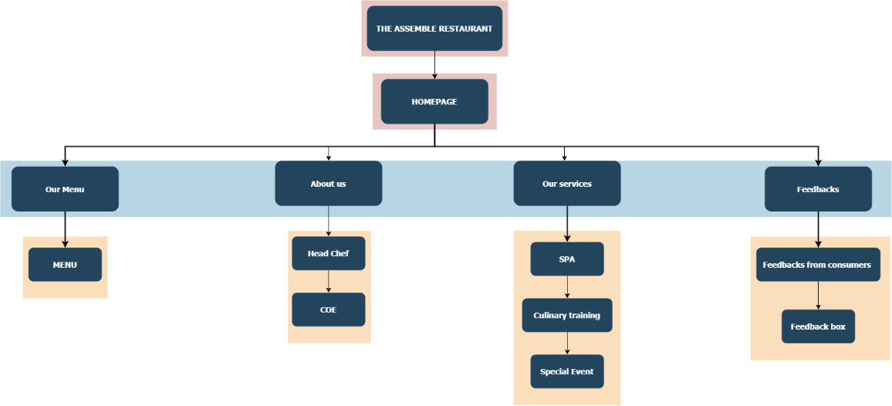

References:

PxHere. Dishes photo. Available at: <https://pxhere.com/en/photo/1636750> (Accessed: 16 December 2022).

Free ICONS Library. LinkedIn icon. Available at: <https://icon-library.com/images/linkedin-icon-black-and-white/linkedin-icon-black-and-white-5.jpg> (Accessed: 19 December 2022).

PnGKIT. Facebook logo. Available at: <https://www.pngkit.com/png/full/10-100309_facebook-like-png.png> (Accessed: 19 December 2022).

PnGKIT. Instagram logo. Available at: <https://www.pngkit.com/png/full/10-100309_facebook-like-png.png> (Accessed: 19 December 2022).

SimilarPNG. Instagram logo. Available at: <https://similarpng.com/instagram-black-and-white-logo-vector-png/> (Accessed: 19 December 2022).

PxHere. Burger picture. Available at: https://pxhere.com/en/photo/1556149 (Accessed: 25 December 2022).

PxHere. Hot dog picture. Available at: <https://pxhere.com/en/photo/841648> (Accessed: 25 December 2022).

PxHere. Sandwich picture. Available at: <https://pxhere.com/en/photo/1084040> (Accessed: 25 December 2022).

PxHere. Pizza picture. Available at: <https://pxhere.com/en/photo/1411428> (Accessed: 25 December 2022).

PxHere. Risotto picture. Available at: <https://pxhere.com/en/photo/423393> (Accessed: 25 December 2022).

PxHere. Salad picture. Available at: <https://pxhere.com/en/photo/1057389> (Accessed: 26 December 2022).

PxHere. Chicken curry. Available at: <https://pxhere.com/en/photo/912656> (Accessed: 26 December 2022).

PxHere. Chicken biryani. Available at: <https://pxhere.com/en/photo/819400> (Accessed: 26 December 2022).

PxHere. Fish picture. Available at: <https://pxhere.com/en/photo/597264> (Accessed: 27 December 2022).

Flaticon. SPA icon. Available at: <https://www.flaticon.com/free-sticker/massage_8686087?term=spa&page=1&position=3&origin=search&related_id=8686087> (Accessed: 27 December 2022).

Flaticon. Cooking icon. Available at: <https://www.flaticon.com/free-sticker/cooking_5684038?term=cooking&page=1&position=7&origin=search&related_id=5684038>

(Accessed: 30 December 2022).

Flaticon. Special event icon. Available at: <https://www.flaticon.com/free-icon/event_2558944?term=events&page=1&position=16&origin=search&related_id=2558944> (Accessed: 30 December 2022).